WhatsApp AI Sales Agent
N8N Automation Report | Main Workflow + Sub-Workflows

Trigger | WhatsApp ,Incoming Text Message (Webhook)
Platform | N8N
Integrations | WhatsApp Business API, Salesforce (JWT OAuth), PostgreSQL (Neon DB), OpenAI, Calendly, 3 Sub-Workflows
AI Model | Configurable per conversation ,default GPT-4o (loaded from DB)
Language | French (fr) ,configurable per lead in database
Output | AI reply sent via WhatsApp; lead data updated in Salesforce & PostgreSQL

Main Workflow ,WhatsApp AI Sales Agent

Workflow Overview
This workflow is a fully autonomous WhatsApp AI sales agent for real estate lead qualification and meeting booking. When an inbound WhatsApp message arrives, the agent authenticates with Salesforce via JWT, looks up the lead's CRM record, loads per-lead configuration and conversation history from PostgreSQL, and routes to an AI agent that can respond intelligently, handle objections using a vector knowledge base, check Calendly availability, book meetings, and progressively update the lead's Salesforce record with qualifying data collected during conversation. Every exchange is persisted to PostgreSQL with intent classification and a dynamic lead score. The system supports human takeover mode, which disables AI responses while continuing to log messages.

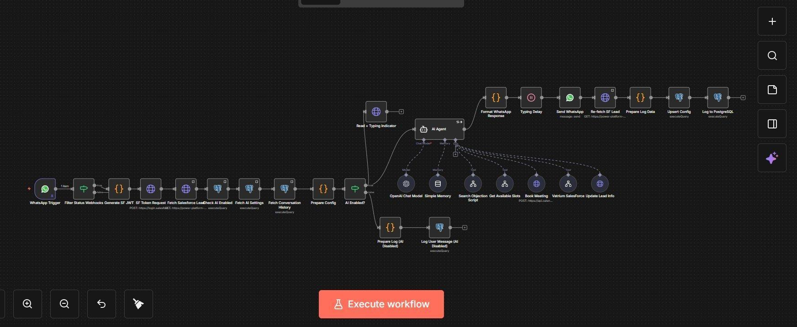

Workflow Architecture ,Two Branches
After loading configuration, the workflow splits based on the per-lead AI status:
- Branch A ,AI Active: Sends a read receipt + typing indicator, runs the full AI Agent pipeline, formats and delivers the reply, then logs everything to Salesforce and PostgreSQL.
- Branch B ,AI Disabled / Human Takeover: Skips AI processing entirely. The incoming message is still intent-classified and logged to PostgreSQL ,keeping history intact for seamless agent resumption.

How It Works ,Step by Step
- Step 1 ,Filter Status Webhooks: Rejects WhatsApp delivery status updates. Only text message events with a non-empty body proceed.
- Step 2 ,Generate SF JWT: A code node generates a signed RS256 JWT token using the Salesforce consumer key, username, and private key ,valid for 3 minutes ,for the OAuth 2.0 JWT Bearer flow.
- Step 3 ,SF Token Request: The JWT is exchanged for a Salesforce access token via a POST to the Salesforce OAuth token endpoint.
- Step 4 ,Fetch Salesforce Lead: The lead's record is queried from Salesforce by matching the last 9 digits of the WhatsApp number against Phone and MobilePhone fields.
- Step 5 ,Check AI Enabled: Per-lead config is fetched from PostgreSQL: ai_enabled, human_takeover, language, objection count, and lead score.
- Step 6 ,Fetch AI Settings: Global AI settings are loaded from PostgreSQL: system_prompt, model name, and max_tokens ,allowing runtime changes without touching the workflow.
- Step 7 ,Fetch Conversation History: The last 20 conversation turns for this lead are fetched from PostgreSQL, ordered chronologically, excluding RELANCE_OPP intent messages.
- Step 8 ,Prepare Config: All data is merged into one config object with strict instructions injected into the system prompt to never re-ask already-provided information.
- Step 9 ,AI Enabled? (Route): If ai_enabled = true AND human_takeover = false, execution goes to the AI branch. Otherwise, the logging-only branch is used.
- Step 10 ,Read + Typing Indicator: A WhatsApp Graph API call marks the message as read and activates the typing indicator.
- Step 11 ,AI Agent: The AI Agent receives the full context and calls tools (objection search, slot lookup, meeting booking, CRM updates) as needed to handle the conversation.
- Step 12 ,Format WhatsApp Response: Internal debug tags are stripped, Markdown is converted to WhatsApp formatting, and text is capped at 4,000 characters with sentence-boundary truncation.
- Step 13 ,Typing Delay: Dynamic wait: 0s if tools were called, up to 12s proportional to response length ,simulating natural typing.
- Step 14 ,Send WhatsApp: Formatted message delivered to the lead via WhatsApp Business API.
- Step 15 ,Re-fetch SF Lead: Salesforce queried again to capture any CRM updates made by tools during the agent's execution.
- Step 16 ,Prepare Log Data: Two log entries assembled (user + assistant), with intent, lead score (from AI [SCORE:] tag), and updated objection count.
- Step 17 ,Upsert Config: Lead config row inserted or updated (ON CONFLICT DO UPDATE) in PostgreSQL with latest score, intent, and Salesforce identifiers.
- Step 18 ,Log to PostgreSQL: Both messages inserted into the conversations table in a single query.

AI Agent Tools
Tool | When & How It Is Used
Search Objection Script | Called when an objection is detected. Triggers the vector search sub-workflow and returns the best matching objection-handling script.
Get Available Slots | Called when lead asks about meeting times. Queries Calendly for slots filtered by date range and preferred hour. Returns UTC start_times for booking.
Book Meeting | Called after slot confirmation. Creates a Calendly invitee with name, email, location, and WhatsApp number. MUST be followed by Vatrium SalesForce tool.
Vatrium SalesForce | Mandatory post-booking. Triggers the SalesForce sub-workflow with full lead qualification data, conversation summary, and event URL.
Update Lead Info | Called progressively when new qualifying data is collected (budget, city, employment, timeline, residential status). PATCHes Salesforce ,only sends actual values.

Intent Classification & Lead Scoring
- OBJECTION: Hesitation, lack of time, disinterest ,increments objection_count in DB.
- RDV_PRET: Lead signals readiness to book or asks about availability.
- QUESTION_TECHNIQUE: Price, size, floors, parking, zones, or financing questions.
- SIMPLE_DISCUSSION: General conversation ,default fallback.
- RELANCE_OPP: Re-engagement messages ,excluded from conversation history fed to AI.

The AI embeds [SCORE:XX] in its response. The Format node extracts this, clamps it 0–100, and stores it in PostgreSQL. If absent, the previous score is retained.

Challenges & Solutions
⚡ Salesforce tokens expire and cannot be hardcoded
→ A fresh RS256 JWT is generated on every execution and exchanged for a short-lived access token, used for all Salesforce calls within that execution.
⚡ AI must never re-ask already-provided information
→ The last 20 conversation turns are injected into the system prompt with an absolute rule never to re-request fields already given by the lead.
⚡ WhatsApp delivers both messages and status updates to the same webhook
→ Filter Status Webhooks checks for a messages array with type=text before any processing, discarding delivery receipts entirely.
⚡ Typing delay must feel natural without wasting time
→ Dynamic formula: 0s if tools were called, otherwise up to 12s proportional to response length ,capped to avoid excessive waits.
⚡ Model, prompt, and token limits need runtime changeability
→ All three are stored in a PostgreSQL ai_settings table and loaded dynamically ,changes take effect on the next message with no workflow edits needed.
⚡ Human agents must be able to take over without losing history
→ When human_takeover = true, the AI branch is skipped but all messages are still logged. When cleared, the AI resumes with full context.

Sub-Workflows
Three sub-workflows called as tools by the AI Agent in the main workflow above.

1 | Search Objection Script

Trigger | Called by AI Agent tool when an objection is detected in the lead's message
Input | user_message ,the raw text of the objection
Integrations | OpenAI Embeddings API, PostgreSQL (pgvector)
Output | Best matching objection-handling script with similarity score, or a fallback response

Automation Flow
1  Generate Query Embedding | 2  Format Query Embedding | 3  Vector Search (pgvector) | 4  Similarity >= 0.3? | 5  Format Found Script / No Match | 6  Merge Output

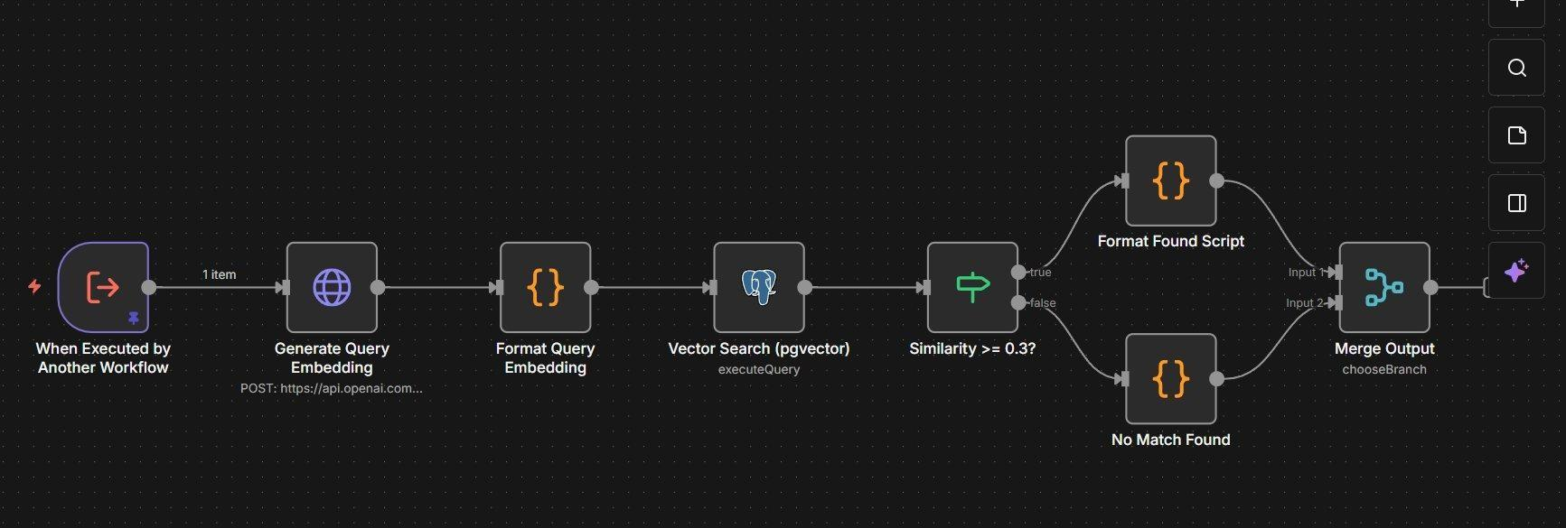

How It Works ,Step by Step
- Step 1 ,Generate Query Embedding: The user's objection message is sent to OpenAI's text-embedding-3-small model (1536 dimensions) via the Embeddings API to produce a semantic vector representation.
- Step 2 ,Format Query Embedding: The returned embedding array is formatted as a pgvector-compatible string ('[0.1, 0.2, ...]') for use in the database query.
- Step 3 ,Vector Search (pgvector): A cosine similarity search is performed against the knowledge table in PostgreSQL, filtering for category='objection' and is_active=true. The single most similar record is returned using the <=> operator.
- Step 4 ,Similarity >= 0.3? (Threshold check): The similarity score is checked against a minimum threshold of 0.3. Below this, the match is considered too weak to use.
- Step 5a ,Format Found Script: If the threshold is met, the matching knowledge record is returned with its title, content (the script), keywords, metadata, and similarity score.
- Step 5b ,No Match Found: If no match meets the threshold, a fallback response is returned instructing the agent to respond naturally using its own judgment.
- Step 6 ,Merge Output: Both branches merge into a single output node (chooseBranch mode), returning one unified result to the parent workflow.

Key Technical Detail ,Vector RAG
This sub-workflow implements a Retrieval-Augmented Generation (RAG) pattern using PostgreSQL's pgvector extension. The knowledge base stores pre-written objection-handling scripts as vector embeddings. When an objection is detected, semantic similarity search finds the most contextually relevant script rather than relying on keyword matching ,handling paraphrased or indirect objections effectively.

2 | Search Available Slots

Trigger | Called by AI Agent tool when lead asks about meeting availability
Inputs | start_time (ISO 8601 UTC), end_time (ISO 8601 UTC), preferred_hour (Paris, 0–23)
Integrations | Calendly API
Output | Compact list of available slots grouped by day with Paris times and UTC start_times for booking

Automation Flow
1  Execute Workflow Trigger | 2  Fetch Calendly Slots | 3  Filter and Summarize Slots

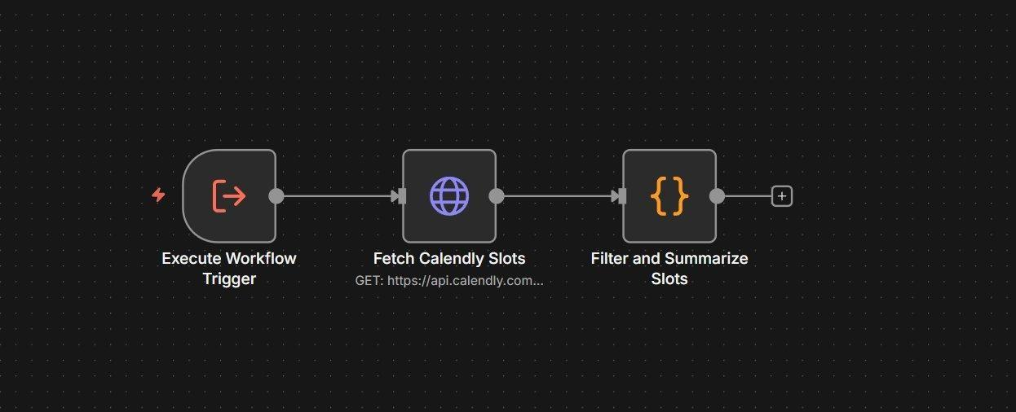

How It Works ,Step by Step
- Step 1 ,Fetch Calendly Slots: Queries Calendly's event_type_available_times endpoint with the requested start_time and end_time (defaults to now+2min → now+6days if not provided). Returns all raw available slot objects.
- Step 2 ,Filter and Summarize Slots: A code node processes the raw slots with several filtering rules: if a preferred_hour is given, only slots within ±2 hours are included; slots are grouped by Paris date; a minimum spacing of 90 minutes (or 30 minutes if filtering by hour) is enforced between displayed slots; max 6 slots per day are shown. Slots closest to the preferred hour are sorted first.

Output Format
The sub-workflow returns a compact, human-readable slot list in French day names with Paris times, plus the UTC start_time in parentheses for the Book Meeting tool to use.

Example: 'Lun 14 avr: 10h00 (UTC: 2026-04-14T08:00:00Z) | 14h00 (UTC: 2026-04-14T12:00:00Z)'

If no slots are found, or if a Calendly API error occurs (e.g., date range exceeds 7 days), a descriptive error message with recovery instructions is returned to the agent.

3 | SalesForce Post-Booking Update

Trigger | Called by AI Agent tool immediately after every successful Calendly booking
Inputs | invitee name/email, location, residential status, professional situation, timeline, meeting datetime, budget, phone, conversation summary, Calendly event URL
Integrations | Calendly API, Salesforce REST API (JWT OAuth)
Output | Salesforce lead updated (or created if not found) with full qualifying data and meeting info

Automation Flow
1  Fetch Calendly Invitee | 2  Map Owner | 3  JWT Generation | 4  SF Token Request | 5  Find Lead | 6  Lead Exists? Route | 7  Update / Create Lead

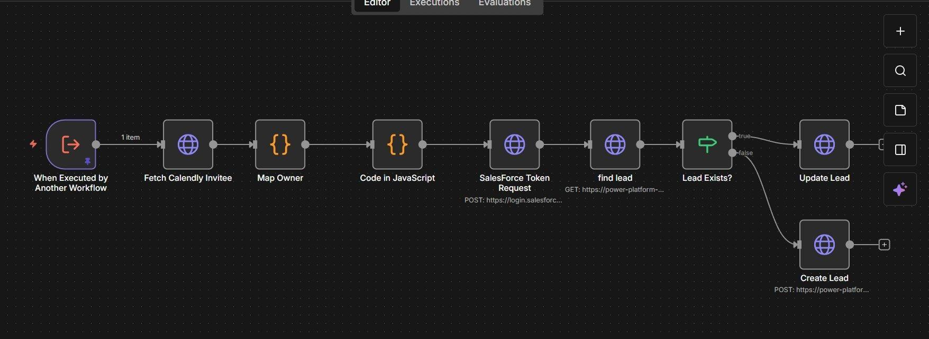

How It Works ,Step by Step
- Step 1 ,Fetch Calendly Invitee: The Calendly event URL passed by the agent is used to fetch the full invitee record from Calendly ,including organizer email, event memberships, and booking metadata.
- Step 2 ,Map Owner: The Calendly organizer's email address is mapped to a Salesforce OwnerId using a hardcoded lookup table. This ensures the lead is assigned to the correct sales advisor in Salesforce.
- Step 3 ,Code in JavaScript (JWT Generation): A fresh RS256 JWT token is generated for Salesforce authentication, identical to the method used in the main workflow ,ensuring this sub-workflow can authenticate independently.
- Step 4 ,SalesForce Token Request: The JWT is exchanged for a Salesforce access token via the OAuth 2.0 JWT Bearer flow.
- Step 5 ,Find Lead: Salesforce is queried to check whether a lead already exists for this phone number (matching last 9 digits against Phone and MobilePhone fields).
- Step 6 ,Lead Exists? (Route): The result branches: if a lead is found (true), it is updated with the new meeting and qualifying data; if not (false), a new lead record is created.
- Step 7a ,Update Lead: PATCH request to the existing Salesforce lead record. Updates meeting datetime, budget, location, residential status, professional situation, personal contribution amount, conversation summary, and marks the meeting as booked.
- Step 7b ,Create Lead: POST request to create a brand-new Salesforce lead with all qualifying fields populated from the booking and conversation data, assigned to the mapped advisor via OwnerId.

Why This Sub-Workflow Runs Independently
This sub-workflow re-authenticates with Salesforce from scratch (JWT → token → API call) rather than reusing the main workflow's token. This is by design: the post-booking update is a separate execution context, and the main workflow's token may have expired or be out of scope. Generating a fresh token guarantees the Salesforce write always succeeds regardless of execution timing.

Complete Tools & Integrations ,All Workflows

Tool / Service | Role
WhatsApp Business API | Inbound trigger, read receipts, typing indicators, reply delivery
Salesforce (JWT OAuth) | Lead lookup, progressive field updates, post-booking conversion
PostgreSQL ,Neon DB | Per-lead config, conversation history, intent, and lead scores
OpenAI (configurable model) | Main AI Agent ,model and prompt loaded dynamically from DB
OpenAI Embeddings API | Generates 1536-dim vector for objection semantic search
PostgreSQL pgvector | Cosine similarity search on objection knowledge base
Calendly API | Available slot queries and meeting booking
N8N Memory Buffer | In-session context window (500 tokens) keyed by wa_id

End of Document

